Data Deduplication using Python

¹Harshada Deshingkar, ²Preeti Desai, ³Shrinidhi Deshmane, ⁴Aarya Deshmukh, ⁵Tanuja Desai, ⁶Sankhya Desai,
⁷Ganesh Ubale

¹Student, Vishwakarma Institute of Technology, 666, Upper Indiranagar, Bibwewadi, Pune, Maharashtra, INDIA - 411 037.
²Student, Vishwakarma Institute of Technology, 666, Upper Indiranagar, Bibwewadi, Pune, Maharashtra, INDIA - 411 037.
³Student, Vishwakarma Institute of Technology, 666, Upper Indiranagar, Bibwewadi, Pune, Maharashtra, INDIA - 411 037.
⁴Student, Vishwakarma Institute of Technology, 666, Upper Indiranagar, Bibwewadi, Pune, Maharashtra, INDIA - 411 037.
⁵Student, Vishwakarma Institute of Technology, 666, Upper Indiranagar, Bibwewadi, Pune, Maharashtra, INDIA - 411 037.
⁶Student, Vishwakarma Institute of Technology, 666, Upper Indiranagar, Bibwewadi, Pune, Maharashtra, INDIA - 411 037.
⁷Professor, Vishwakarma Institute of Technology, 666, Upper Indiranagar, Bibwewadi, Pune, Maharashtra,INDIA - 411 037.

Email: ¹harshada.deshingkar22@vit.edu, ²preeti.desai22@vit.edu, ³shrinidhi.deshmane22@vit.edu, ⁴aarya.deshmukh22@vit.edu, ⁵tanuja.desai22@vit.edu, ⁶sankhya.desai22@vit.edu, ⁷ganesh.ubale@vit.edu.
Contact: ¹8888162255, ²7249671204, ³9503601685, ⁴9623845879, ⁵9637565171, ⁶7796294198, ⁷9970775232.

Abstract:. This paper aims to develop a data deduplication technique for optimizing storage utilization in enterprise environments and for general users. Data deduplication is a process that identifies and eliminates duplicate data from storage systems, resulting in reduced requirements and lower costs. The project involves working on duplicate files from the folders present in storage systems and processing them to reduce the redundancy of data. The results of the project will provide valuable insights on usage of data deduplication technique to delete duplicate files. This method can be used by users to optimize their storage utilization and reduce their storage costs. Additionally, the project will contribute to the field of data storage and management by providing a way to reduce the constant storage of duplicate files.
Index terms: Data deduplication, python, storage utilization, Inline deduplication, Post-processing Deduplication.

- INTRODUCTION

- Data Deduplication

Data deduplication is a technique using which we can eliminate duplicate version(s) of data. This technique is successfully implemented to optimize the utilization of storage space.

The amount of free space that can be obtained through data deduplication depends on the specific dataset being analyzed on the target volume.

One of the benefits of data deduplication is its ability to reduce costs associated with maintaining duplicated data, particularly for large datasets.
The extent of the cost savings and benefits obtained from data deduplication will vary depending on the nature of the data being analysed.

For example, the user may receive multiple copies of one file from different sources containing the same data. All these files get stored, creating multiple copies of a single file that consumes larger storage space. However, data deduplication can remove these duplicate copies, keeping the original untouched.

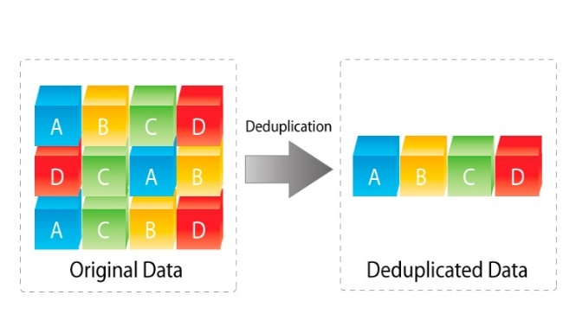

Figure 1: Original data and data post deduplication

Source-https://www.hsb.nl/wp-content/uploads/2021/06/deduplication_diagram.jpg

- Types of Data Deduplication.

There are various methodologies by which data deduplication can be achieved which are as follows-

- In-line Deduplication
- Post-processing Deduplication
- Target Deduplication
- Source Deduplication etc.

Moreover, the insights on types of data deduplication are given by authors in [1] [2].

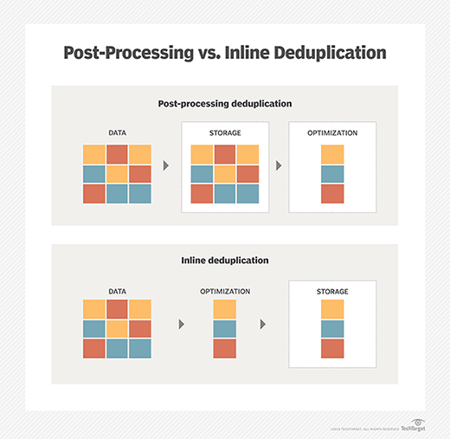
Post-processing deduplication is used by us and it can be understood from the following image-

Figure 2: Post-processing deduplication.

- Data Deduplication vs Data Compression

Data deduplication and data compression are two distinct techniques used to optimize storage and reduce data redundancy.

Data deduplication: Data deduplication algorithms examine massive amounts of data and locate identical files or portions of files. These sections or files are removed by keeping single copy, resulting in a reduction in the overall storage capacity required.

Data Compression: Data compression focuses on reducing file size. Data compression algorithms like LZ77 and LZ78 work by identifying and encoding redundant data within a single file, resulting in smaller file sizes.

Data deduplication targets the elimination of duplicate data to reduce storage space consumption. This makes data deduplication an effective technique for reducing storage costs.

- METHODOLOGY

We have worked on various codes in python that can help detect duplicate files. The best-suited method involves using a hash function to detect duplicate files.
The program first accesses the folder and files that need to be checked for duplicates. Then it looks for duplicate files and deletes them.

In doing so, hashing (a type of data structure) is used [2] [3]. It is a procedure that employs keys to map the data and uses a hash function to create a hash table from the values. It is done for faster access to elements. The effectiveness of the hash algorithm employed affects how efficiently data is mapped.

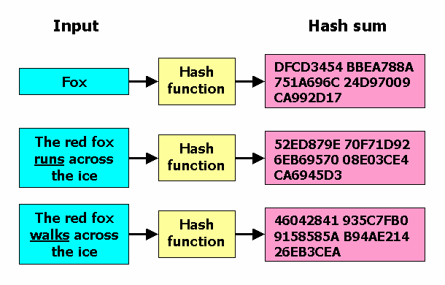

Figure 3: Working of a hash function on duplicates.

So, if the corresponding hash files of two or more files are the same then the duplicate files will be deleted, keeping the latest copy as it is.

The workflow is as shown below-

Accessing the folder and files

Detecting duplicate files

Deleting duplicate files

- ALGORITM
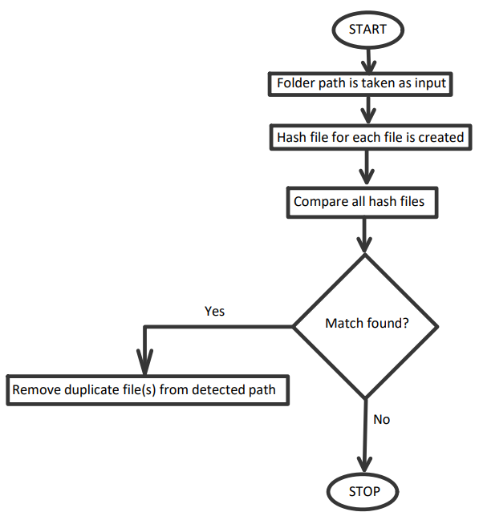

Figure 4: Algorithm used for deduplication.

- SCOPE OF EXECUTION

- The user must have any python IDE and python installed in his/ her device, which will allow smooth execution of program.
- If the files are of different types (having different extensions), then they would not be compared even if they contain same data.
- It is not globally accessible to any user.
- This is limited to hard disk and does not involve cloud storage analysis and secCloud [4].
- Does not fit under the secure deduplication methods [1].
- Even if there is slightest of the change in the file, it would not be deleted.

- TESTING

We have made multiple codes for deduplication and finalized the best one.
It has been tested by multiple users and it is found that the code successfully deletes the duplicate files.

IMAGES:

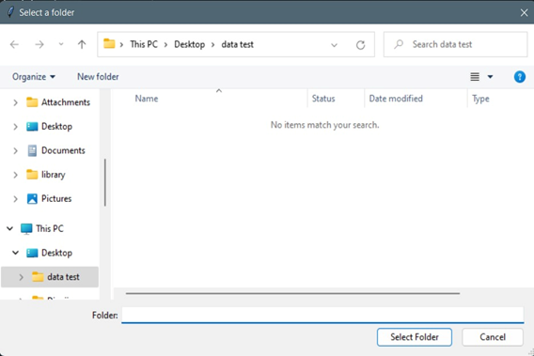

Figure 5: Selecting a folder path.

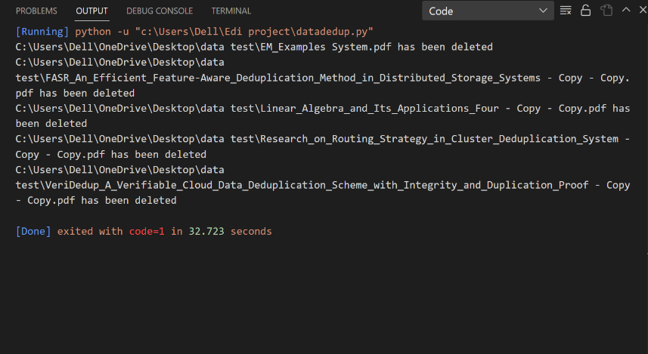

Figure 6: File(s) have been deleted.

- FUTURE SCOPE

- We will give flexibility to user to choose whether he/she wants to delete some specific detected duplicate file(s) or not.
- Even if there is slightest of the change in the file, it would be detected.
- We will work on how to implement deduplication technique on cloud storage.
- We will also work on using a more secure method with secure deduplication as stated in [4] [5].

- CONCLUSION

- Thus, we have made a project that helps organizations and common people to optimize storage utilization and reduce redundant data.
- The above data deduplication technique makes sure that there is only one distinct instance of the data on the storage disc.

- ACKNOWLEDEMENT

We would like to pay gratitude to our college, Vishwakarma Institute of Technology, Pune to give us this opportunity. We are thankful to our project guide Prof. Ganesh Ubale sir for guiding us excellently throughout the Engineering Design and Innovation (EDAI) Project. We are grateful to Dr. Chandrashekhar Mahajan Sir for encouraging us to work on this project. We would also like to thank our First Year Department for giving us such a great platform to showcase our skills.

- REFERENCES

[1] | Nipun Chhabra and Manju Bala, "A Comparative Study of Data Deduplication," 2018 First International Conference on Secure Cyber Computing and Communication (ICSCCC), 2018.
[2] | M. L. T. L. Ruijin Zhou, "Characterizing the Efficiency of Data Deduplication for Big Data Storage Management," 2013.
[3] | A. Sharma, Data Analysis & Interpretation, McGraw Hill Education, 2018.
[4] | G. M. SAJJA KRISHNA KISHORE, "AN ADVANCED SECURE AUDITING AND DATA DE DUPLICATING," International Journal of Advanced Computational Engineering and Networking, vol. 4, no. 11, 2016.
[5] | M. R. K. Mahdi Abbasi, P. G. Shynu, K. N. R., G. V. Menon and V. P., "A secure data deduplication system for integrated cloud-edge networks," Journal of Cloud Computing: Advances, Systems and Applications, 2020.
[6] | M. H. Joe Reis, Fundamentals of Data Engineering: Plan and Build Robust Data Systems, O'Reilly Media, 2022.
[7] | A. V. K. P. V. K. Niteesha Sharma, "Data Deduplication Techniques for Big Data Storage Systems," International Journal of Innovative Technology and Exploring Engineering (IJITEE), vol. 8, no. 10, 2019.

